Task 1: Binary Search Tree (20 points)

main.cpp is a binary search tree (BST) implementation. The code has some bugs/poor

coding styles. You have to find the problematic lines of the code and add review

comments. Problems may include:

* Indentation is not right.
* Assignment operator misused.
* Wrong comments in function description.
* Flaws in case statement etc.

Additional screenshots below.

* 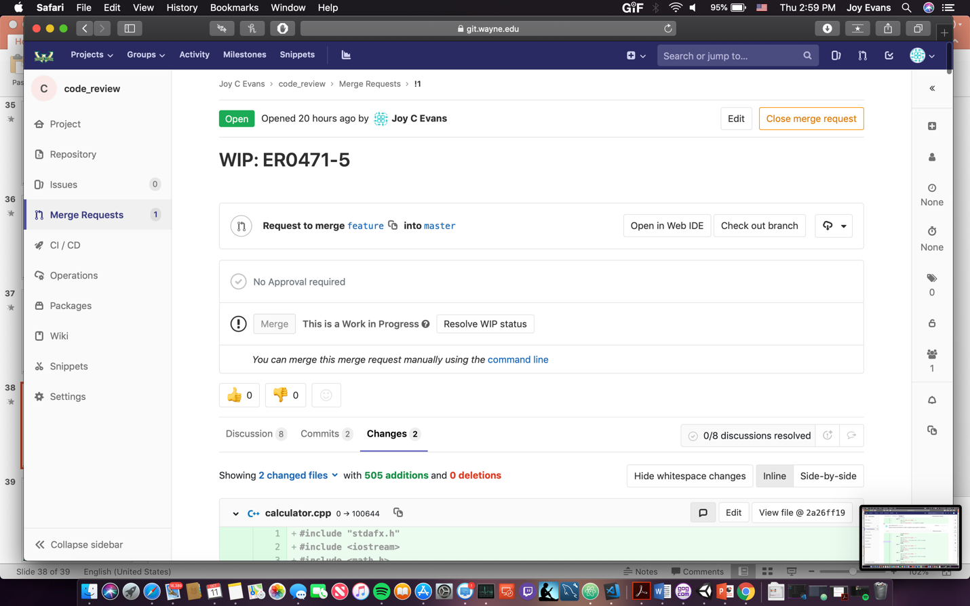

**Calculator.cpp**

|  |  |
| --- | --- |
| Line number | Comment |
| 10 | Program does not take into account a negative exponent. Function will not work properly. |
| 34 | Division calculation does not take into account division by zero which is undefined. |
| 66 | Program does not take into account a negative exponent. Function will not work properly. |
| 72 | Square root will not be defined is number is negative causes program to malfunction. |

**Calculator.cpp**

|  |  |
| --- | --- |
| Line number | Comment |
| 70 | Use of assignment operator. Case will not work properly. |
| 109 | This comment should refer to finding an element in the tree instead of inserting. |
| 153 | Assignment operator used. Should be equality comparison: if (root == NULL) |
| 224 | Improper indentation. Brackets and proper indentation will help to differentiate between the multiple if statements. |

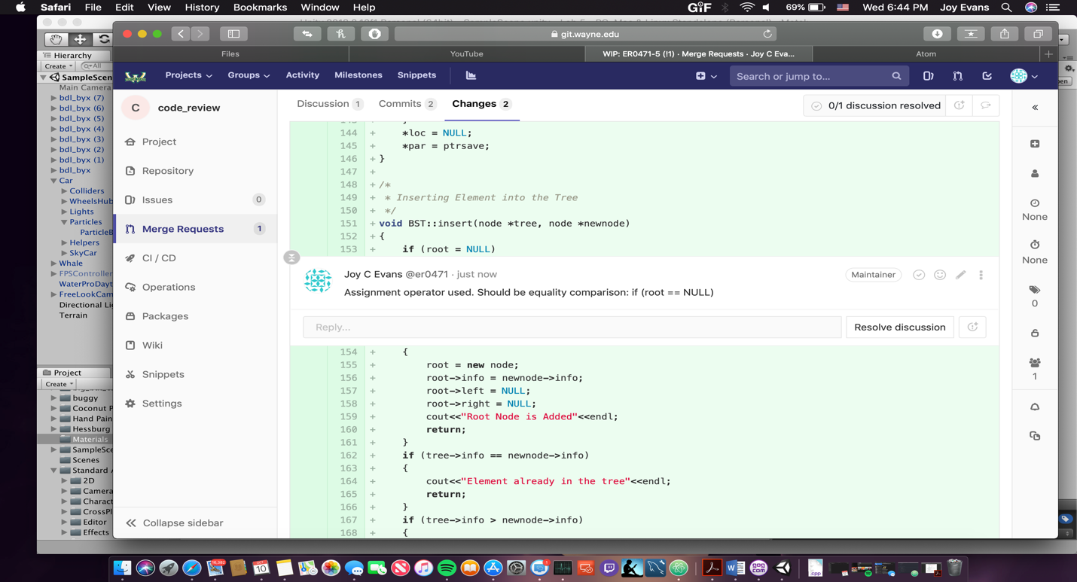

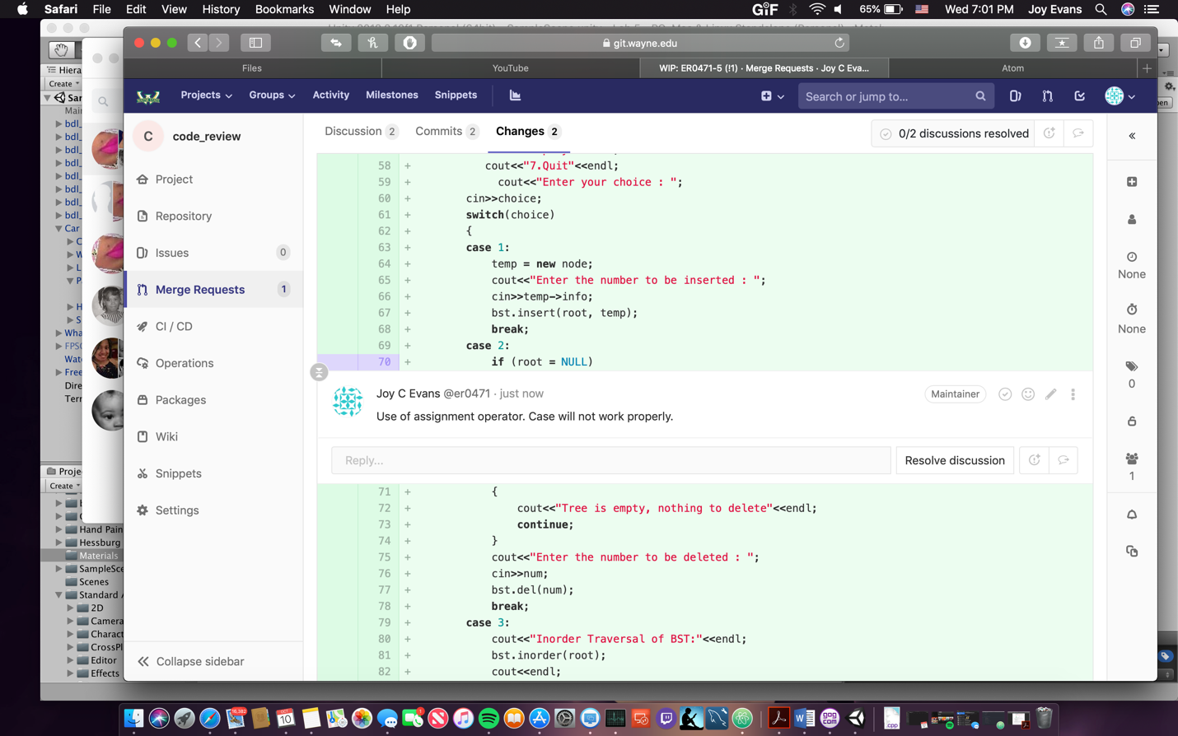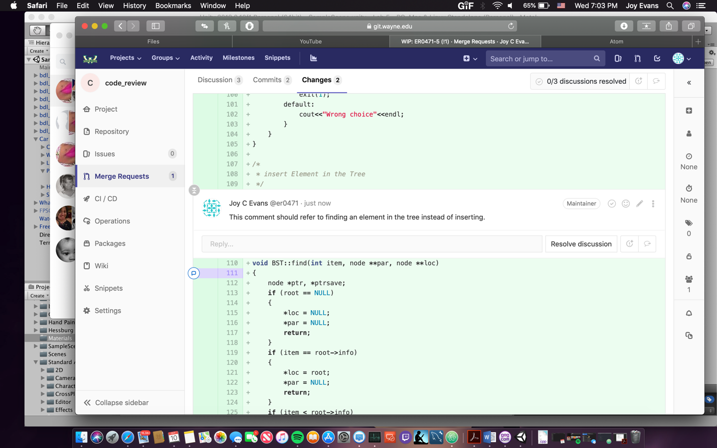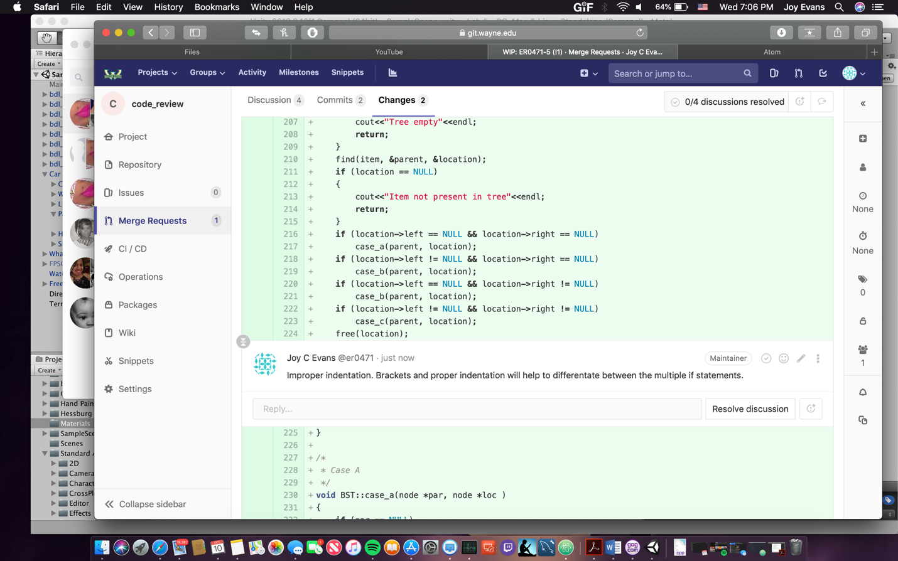

You have to find at least one for each of above categories of problems.

Task 2: Calculator (20 points)

calculator.cpp is an implementation of a simple calculator. Errors in this project mainly

related to validation. For example, divide function may not be applicable for all inputs.

You have to find at least four bugs in this project and add comments for them in code

review.

